Bocboc, Don Gefer Q. Sept. 17, 2025

BSCS-1B ACTIVITY #

Create a diagram showing internet connectivity consider the following:

* User device
* Wi-Fi/Cable/Fiber
* Router
* ISP
* Internet Backbone
* Server
* 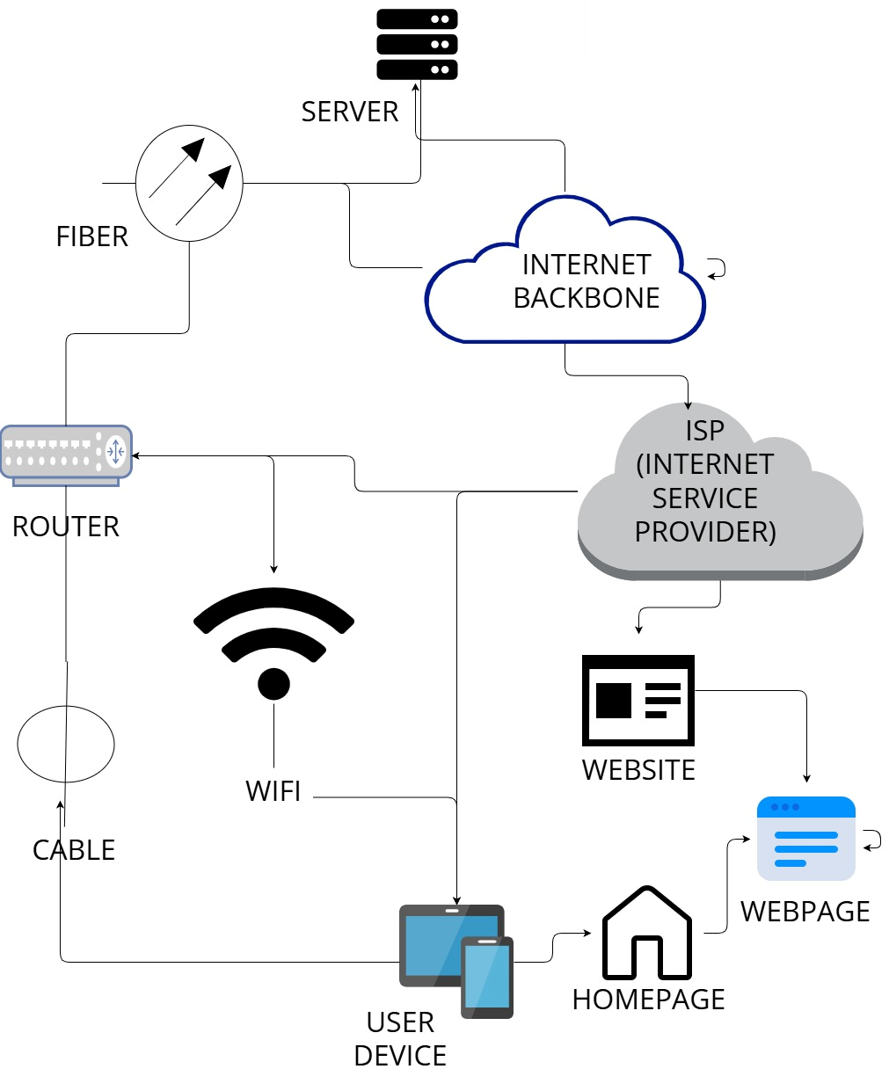Website/webpage/Homepage